About us:  
  
**Built to empower domain-experts**

Having worked with both the manufacturing domain-expert and a software experts, we have seen in close on transferring the intricate complexities of a manufacturing process and requirements. Industry 4 at it's utmost capacity can be achieved through an agile methodology with quick feedback and development loops. We set out to enable this for the industries by putting the tools in the hands of the domain experts that abstracts the software behind the scenes

**Founder Journey**

I have always been thrilled to find solutions to problems by the means of electronics and software. An electronics engineer with software development knowledge dropped into the shop-floor of a multinational manufacturing firm opened up new perspective for problems whose solution was in the synergy of multiple fields.

Four years post spending eight months on the shop-floor and with two years of experience building firmware for Fieldbus Protocols, the decision to contribute to the manufacturing industry was taken.

I believed the recipe to success is through empowering people and I set out to build for the people I worked with with the skills from software and electronics development.



**Never miss out on updates**

Join our newsletter to stay up to date on the latest trends and features

Top of Form

Bottom of Form

[MachDatum on LinkedIn](https://www.linkedin.com/company/machdatum)[MachDatum on GitHub](https://github.com/machdatum)[MachDatum on Instagram](https://instagram.com/machdatum)

© 2025 MachDatum. All rights reserved.

**Modules**



[ThingConnect](https://thingconnect.io/)



[ThingSight](https://www.machdatum.com/thingsight)



[CMMS](https://www.machdatum.com/cmms)

**Features**



[Asset Management](https://www.machdatum.com/asset-management)



[Work Order Management](https://www.machdatum.com/work-order-management)



[Spare Part Management](https://www.machdatum.com/spare-part-management)

**Resources**



[Blog](https://www.machdatum.com/blogs)



[Use Cases](https://www.machdatum.com/use-cases)



[Articles](https://www.machdatum.com/articles)

**Company**



[About Us](https://www.machdatum.com/our-story)



[Our Team](https://www.machdatum.com/people)



[Contact Us](https://www.machdatum.com/contact-us)



[Privacy Policy](https://www.machdatum.com/privacy-policy)

**Devices**



[RS485 to Ethernet Converter](https://www.machdatum.com/devices/rs485-to-ethernet-converter)



[RS485 to WiFi Converter](https://www.machdatum.com/devices/rs485-to-wifi-converter)

**Contacts**



+91 7200590352



[contact@machdatum.com](mailto:contact@machdatum.com)



4C, KP Towers, Valluvar St, Karuparayanpalayam, Coimbatore 641 062

Home:  
  
**Accelerate Industry 4, on your terms**

Connect, Integrate, Monitor and Automate shop-floor operations for improved asset and process efficiency

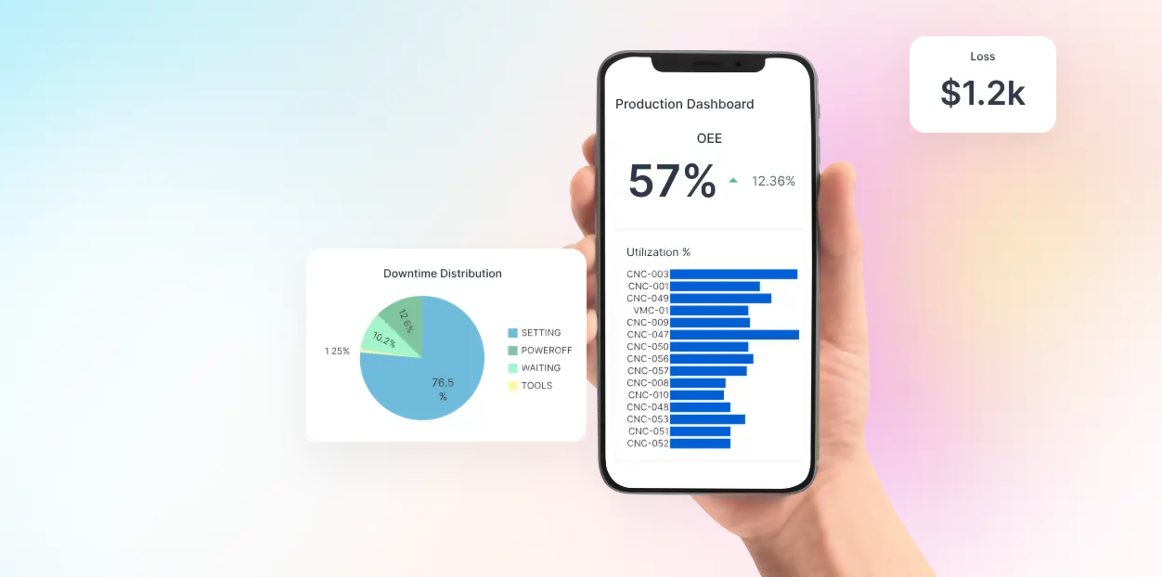



**Connect your field-devices**

Extend your field devices within the OT network and bring them to the IT infrastructure to extract the best from the synergy



**Monitor & Analyze your shop-floor**

Build holistic live dashboards and reports with user defined Key Performance Indicators and gain end-to-end visibility into your operations



**Automate your workflows**

Super-charge interactions between man, process and machine with real-time stream processing and workflow automations



**What Our Clients Say**

Haritha Priyadarshini

Partner

, Haritha's Cartapack

**Enabled better decision making**

MachDatum's products provided us the much needed transparency into our manufacturing line enabling better decision making and identifying bottle necks in the process  
  
Team Members:

**Meet our Team**

Our talented team blends skills and experiences, driving our success. Meet the people shaping our vision and making a difference.

**Dr M Ramasamy**

Managing Director

**Hemanand Ramasamy**

CEO

**Noufal Basheer N**

IOT Lead

**Devadharshini**

Technical Lead

**Keerthanaa G S**

Product Lead

**Kavya P**

Embedded Engineer

**Gokul Vijay**

Senior SDE

**Dharshini S**

SDE

**Sanjana M**

SDE

Contact us - **Let's Connect**

Questions? Ideas? Looking for support? We're here for you. Drop us a message and we'll be in touch soon.

Explore use cases tailored to your industry

Get help navigating the MachDatum platform or discuss your project needs

Speak with experts about digital transformation, system integrations, or KPIs

Learn more about our pricing, deployment, or customization options

Whether it's a quick query or a deep dive, we're ready to respond

Expect timely and thoughtful responses from real humans

Let's explore how we can empower your team and operations together

Request technical support or troubleshooting help

Your success is our mission — and every conversation starts here

Start a conversation that could shape your digital future

  
  
Blogs:  
  
[**https://www.machdatum.com/blogs**](https://www.machdatum.com/blogs)

Stay up to date with insights, news, and updates from the MachDatum team



August 25, 2025

**The 7 Most Important CMMS Maintenance KPIs Every Manufacturer Must Track in 2025**

CMMS

KPI



August 5, 2025

**What is 3W1H? A Practical Framework for Solving Problems on the Factory Floor**

3W1H

5 Whys

Fishbone



July 16, 2025

**A3 Thinking in Toyota: Origins, Evolution, and Impact on Lean Manufacturing**

A3

Toyota

Lean Manufacturing

TPS



July 9, 2025

**Mistake-Proofing Your Factory: A Practical Guide to Poka-Yoke**

Poka-Yoke

Mistake-Proofing

TPS



July 2, 2025

**The Power of Asking Why: A Deep Dive into RCA**

RCA

Why Analysis

Ishikawa

Pareto

FTA



January 18, 2025

**Unlock Manufacturing Nirvana: Transform Your Process with 7 QC Tools**

7 QC Tools

Check Sheet

Control Chart

Histogram

Pareto Chart



December 11, 2024

**The 7 Samurai of Quality: Master Simple Tools to Vanquish Defects - 7QC Tools**

7QC Tools

Check Sheet

Control Chart

Histogram



December 11, 2024

**Unleashing the Power of 7QC Tools in Manufacturing Industry: A Comprehensive Guide**

7QC Tools

Lean Tools

QC Circle



October 22, 2024

**Revealing Hidden Defects: How Digital Quality Management Processes Save Your Reputation**

DQM



October 14, 2024

**From Chaos to Control: Taming the Quality Beast with Digital Transformation**

Digital Transformation

IoT

Use Cases:  
**Use Cases**

Discover how our solutions are transforming industrial operations — real examples, real impact



**Nitriding Process Optimization for Gearbox Components**

Saved 3 hours per charge and boosted furnace utilization by 10% through automated planning of component-fixture combinations for the nitriding heat treatment process



**Assembly Digitalization and Digital Valve Test Certificate**

Streamlining Material Test Certificates, Hydro Testing, and ERP Data to ensure faster, accurate, and automated certification generation



**Wireless Process Monitoring for Kiln Operations**

Eliminated 1,344 daily manual entries by deploying a wireless, BLE-based monitoring system for real-time temperature tracking across kilns



**Utility Monitoring & Safety Automation**

Transformed manual utility tracking into a real-time, automated system—enabling sustainability reporting, energy optimization, and safety alerts for gas and oxygen levels



**Smart Production Monitoring for Cone Manufacturing**

Enabled live production tracking and predictive spare part alerts empowering the owner with visibility and improving quality consistency



**Digital Quality Certificate for Gearbox Assemblies**

Enabled automatic generation of digitally signed Quality Certificates by integrating siloed quality data across

Articles:  
**Our Articles**

Discover technical insights, product updates, and stories from the MachDatum team



July 26, 2025

**MachDatum’s MDIM485: The Reliable Gateway Between RS485 and Ethernet**

Product – RS485 to ethernet converter

**Product Overview**

The MDIM-485 Single-Port Gateway provides a reliable and cost-effective solution for bridging Modbus RTU serial devices to Modbus TCP Ethernet networks. This compact industrial-grade device offers transparent protocol conversion, enabling seamless integration of legacy serial equipment into modern IP-based automation systems.

**Key Benefits**

**Protocol Conversion**

Transparent bidirectional conversion between Modbus RTU and Modbus TCP protocols without data loss or corruption.

**Industrial Reliability**

Designed for harsh industrial environments with -40 to 75°C operating temperature range and enhanced protection.

**Easy Integration**

Plug-and-play functionality with user-configurable parameters for quick deployment in existing systems.

**Made in India**

Locally manufactured with 2-year warranty and free technical support from MachDatum.

**Related Devices**

Explore other products in our RS485 converter lineup  
  
**What is an RS485 to Ethernet Converter?**

An RS485 to Ethernet Converter is a device that enables communication between RS485 serial devices and Ethernet networks. It converts RS485 Modbus RTU protocol to Ethernet Modbus TCP/IP protocol, allowing legacy industrial equipment to connect to modern IP-based networks for remote monitoring and control.

**How It Works**

The converter acts as a bridge between two different communication protocols:

**RS485 Side (Serial)**

* Connects to Modbus RTU devices
* Uses differential signaling
* Up to 921.6 kbps baud rate
* Reliable long-distance communication

**Ethernet Side (Network)**

* Connects to TCP/IP networks
* Standard RJ45 connection
* 10 Mbps Ethernet performance
* Remote access capability

**Why Use an RS485 to Ethernet Converter?**

Modern industrial facilities often have a mix of legacy RS485 equipment and new Ethernet-based systems. Rather than replacing expensive working equipment, an RS485 to Ethernet converter provides:

* Cost-effective integration of legacy equipment
* Remote monitoring and control capabilities
* Network-based data collection and analysis
* Cloud connectivity for IoT applications
* Centralized SCADA system integration

**Category**

**Parameter**

**Specification**

**Communication Interfaces**

**Ethernet Communication**

Protocol Support

Modbus TCP

Data Rate

10 Mbps

Network Interface

1× Ethernet (RJ45)

**Serial Communication**

Port Type

RS-485

Number of Ports

1

Baud Rate

50bps – 921.6kbps

Protection

Surge protection, ESD protection

**Electrical Specifications**

**Power Requirements**

Input Supply (Screw Terminal)

6VDC – 24VDC

Input Supply (Power Jack)

6VDC – 24VDC

Operating Current

600mA

Power Consumption

3W @ 200mA

**Physical Specifications**

**Mechanical**

Housing

Metal

Dimensions

82 x 51.5 x 23 cm (L x W x H)

Weight

160.4g

**Environmental Specifications**

**Operating Conditions**

Operating Temperature

-40°C to 75°C (-40°F to 167°F)

Storage Temperature

-40°C to 85°C (-40°F to 185°F)  
  
**Applications & Use Cases**

The MDIM-485 RS485 to Ethernet Converter is designed for diverse industrial applications where reliable serial-to-network communication is essential.

**Industrial Automation**

Connect PLCs (Programmable Logic Controllers) to SCADA (Supervisory Control and Data Acquisition) systems for real-time factory floor monitoring. Enable remote control of production lines and automated manufacturing processes with centralized data collection.

**Building Automation & HVAC**

Integrate HVAC systems, energy management devices, and access control systems into building management networks. Monitor and control temperature, ventilation, and lighting systems remotely from a central location.

**Smart Grid & Energy Monitoring**

Monitor solar inverters, energy meters, and power distribution equipment in real-time. Collect consumption data for analysis and optimization. Enable predictive maintenance for critical power infrastructure.

**IoT & Remote Monitoring**

Connect remote sensor networks for environmental monitoring, asset tracking, and condition monitoring. Enable cloud connectivity for data analytics and visualization. Support predictive maintenance and early warning systems.

**MDIM-485/WL**

**RS485 to WiFi Converter**

Made in India

Industrial WiFi gateway with wireless connectivity and MQTT support for cloud integration.

**Key Features:**

WiFi + Ethernet dual connectivity

MQTT protocol support for cloud

Modbus RTU to Modbus TCP conversion

2-year warranty

Made in India

Product – RS485 to Wi-FI Converter  
  
**RS485 to WiFi Converter - MDIM485/WL**

Industrial WiFi Gateway with Modbus RTU to TCP & MQTT Support

Made in India

**₹3,500**

₹5,999

**Save 42%**

Inclusive of all taxes • Free shipping on orders above ₹10,000

WiFi + Ethernet Dual Connectivity

MQTT Protocol Support for Cloud Integration

Wide Operating Temperature Range (-40 to 75°C)

Support for Multiple RTU Slaves

2-Year Warranty with Free Technical Support

**Product Overview**

The MDIM-485/WL is a compact, high-performance gateway that seamlessly connects RS485 devices to modern IP-based systems via 10 Mbps Ethernet or 2.4 GHz Wi-Fi. Built for demanding industrial environments, it offers transparent, real-time Modbus RTU to Modbus TCP conversion with support for multiple simultaneous client connections. Featuring dual DC power inputs, wide voltage support, and advanced surge/ESD protection, it ensures reliable operation even in extreme conditions. With its plug-and-play setup and intuitive configuration software, integrating the MDIM-485-WL into your existing infrastructure is fast and effortless.

**Key Benefits**

**Protocol Conversion**

Transparent, bidirectional Modbus RTU over Modbus TCP conversion without data loss or delay.

**Multi-Client Support**

Allows multiple systems to access RTU devices simultaneously for parallel operations.

**Industrial Reliability**

Operates from -40°C to +75°C with rugged housing and enhanced surge/ESD protection.

**Dual Connectivity**

Flexible communication via Ethernet or 2.4 GHz Wi-Fi for diverse applications.

**Easy Integration**

Plug-and-play functionality with configurable parameters for quick deployment.

**What is a Wireless RS485 to Ethernet Converter?**

A Wireless RS485 to Ethernet Converter is an industrial IoT gateway that bridges RS485 serial devices with modern Ethernet and WiFi networks. The MDIM-485/WL converts RS485 Modbus RTU protocol to Ethernet Modbus TCP/IP protocol wirelessly, enabling legacy industrial equipment to connect to IP-based networks, cloud platforms, and SCADA systems without physical Ethernet cables.

**How It Works**

The converter acts as a wireless bridge between two different communication protocols:

**RS485 Side (Serial)**

* Connects to Modbus RTU devices
* Uses differential signaling
* Up to 921.6 kbps baud rate
* Reliable long-distance communication

**Wireless/Network Side**

* WiFi 2.4 GHz (802.11 b/g/n)
* Ethernet RJ45 connection
* MQTT protocol support
* Cloud platform integration

**Why Use a Wireless RS485 to Ethernet Converter?**

Modern industrial facilities often have a mix of legacy RS485 equipment spread across large areas. Running Ethernet cables can be expensive and impractical. A wireless RS485 to Ethernet converter provides:

✓ Cost-effective wireless integration  
✓ Flexible device placement  
✓ Remote monitoring and control  
✓ MQTT and cloud connectivity

✓ No cable installation costs  
✓ Easy relocation of equipment  
✓ Multi-client access  
✓ Real-time data collection

**Category**

**Parameter**

**Specification**

**Communication Interfaces**

**Ethernet Communication**

Protocol Support

Modbus TCP

Data Rate

10 Mbps

Network Interface

1× Ethernet (RJ45)

**Wireless LAN Communication**

Compatibility

IEEE 802.11a/b/g/n

Network range/Speed

2.4 GHz, 150Mbps

Free space range

Open space 100m

**Serial Communication**

Port Type

RS-485

Number of Ports

1

Baud Rate

50bps – 921.6kbps

Protection

Surge protection, ESD protection

**Electrical Specifications**

**Power Requirements**

Input Supply (Screw Terminal)

6VDC – 24VDC

Input Supply (Power Jack)

6VDC – 24VDC

Operating Current

600mA

Power Consumption

3W @ 300mA

**Physical Specifications**

**Mechanical**

Housing

Metal

Dimensions

82 x 51.5 x 23 cm (L x W x H)

Weight

160.4g

**Environmental Specifications**

**Operating Conditions**

Operating Temperature

-40°C to 75°C (-40°F to 167°F)

Storage Temperature

-40°C to 85°C (-40°F to 185°F)

Ambient relative humidity

5 to 95% RH

**Applications**

**Industrial Automation**

Connect PLCs, VFDs, and industrial controllers to SCADA systems wirelessly. Ideal for factory floors where cable runs are difficult or expensive. Enables centralized monitoring of distributed manufacturing processes.

**Building Automation**

Wireless connectivity for HVAC systems, energy meters, and BMS controllers. Perfect for retrofitting existing buildings without disrupting operations. Enables smart building solutions with minimal installation costs.

**Solar & Energy Management**

Monitor solar inverters, battery management systems, and energy meters across large solar farms. WiFi connectivity eliminates the need for extensive cabling in outdoor installations. Cloud integration for remote monitoring.

**Water & Environmental Monitoring**

Wireless sensor networks for water quality monitoring, tank levels, and pump control. MQTT support enables real-time alerts and data logging to cloud platforms. Ideal for remote or hard-to-reach locations.

**Transportation & Infrastructure**

Monitor traffic controllers, railway signaling systems, and tunnel ventilation. WiFi eliminates cable requirements in distributed infrastructure applications. Enables predictive maintenance through continuous data collection.

**Smart Agriculture**

Wireless connectivity for irrigation controllers, soil sensors, and greenhouse automation. MQTT integration enables mobile monitoring and control. Cost-effective solution for large agricultural areas.  
  
ThingConnect :  
  
  
  
ThingSight:   
  
Bringing data from your operational systems like Customer Relationship Management, Enterprise Resource Planning and Manufacturing Execution System along with your shop-floor data allows you to define accurate Key Performance Indicators that tells you where the highest ROIs are.

**Datasource**

Connect your data from multiple vendors into a single platform, define the logic from the unique identification of assets. Define your own dimensions and metrics using SQL enabling flexibility



**Assets**

Bringing in your shop-floor hierarchy to the BI. Define soft-assets and attach them to multiple data sources, build hierarchies with grouping and level definitions to reflect your shop-floor structure



**Visualizations**

Build holistic dashboards that encompass multiple metrics using pre-built charts or bring your own widgets for visualization. Build on your metrics using JavaScript snippets enabling unrestricted flexibility.

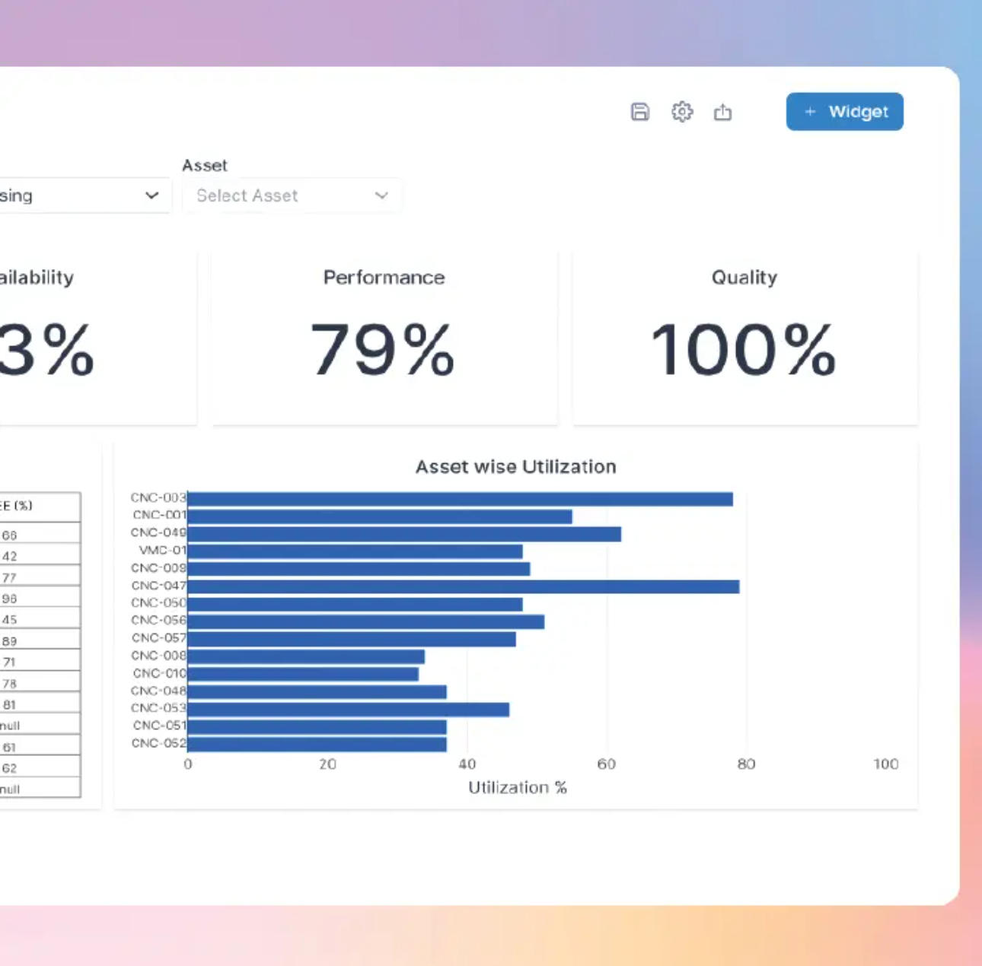

CMMS:

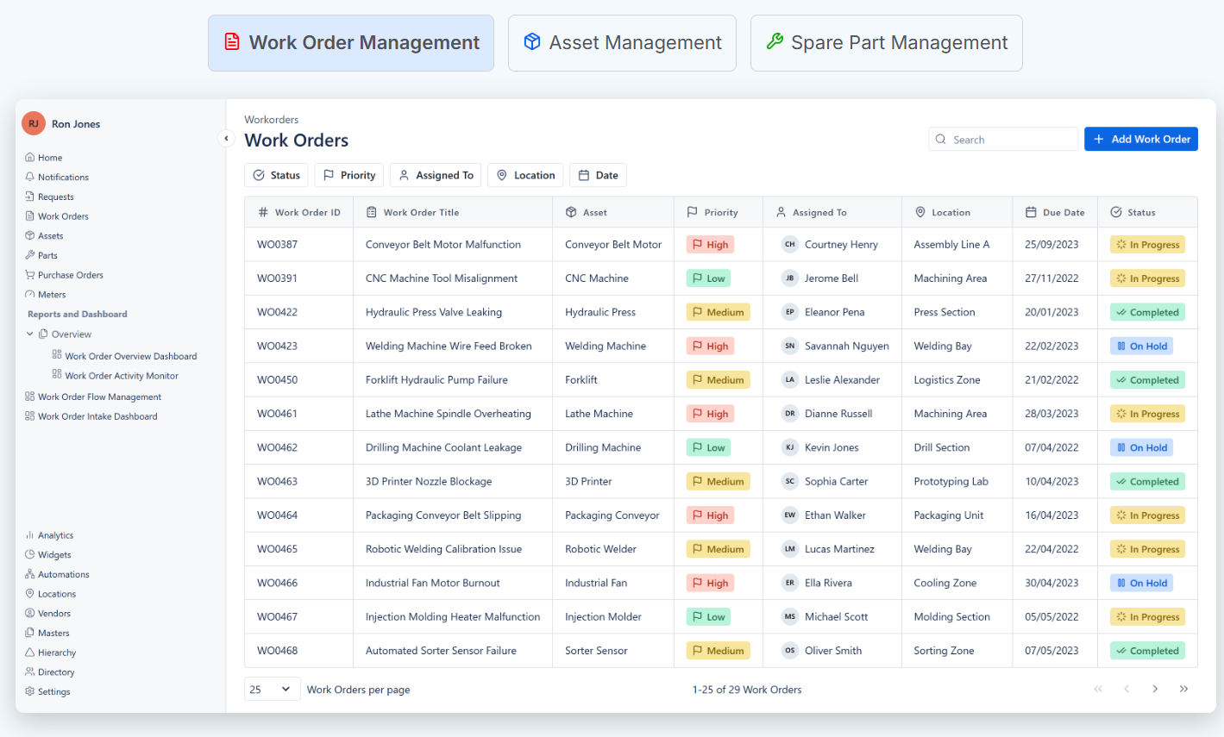  
  
**Work Order Management**

Digitize and centralize your maintenance operations to gain control over every work order. From preventive maintenance to emergency repairs, manage it all from one place — with real-time tracking, analytics, and mobile access.

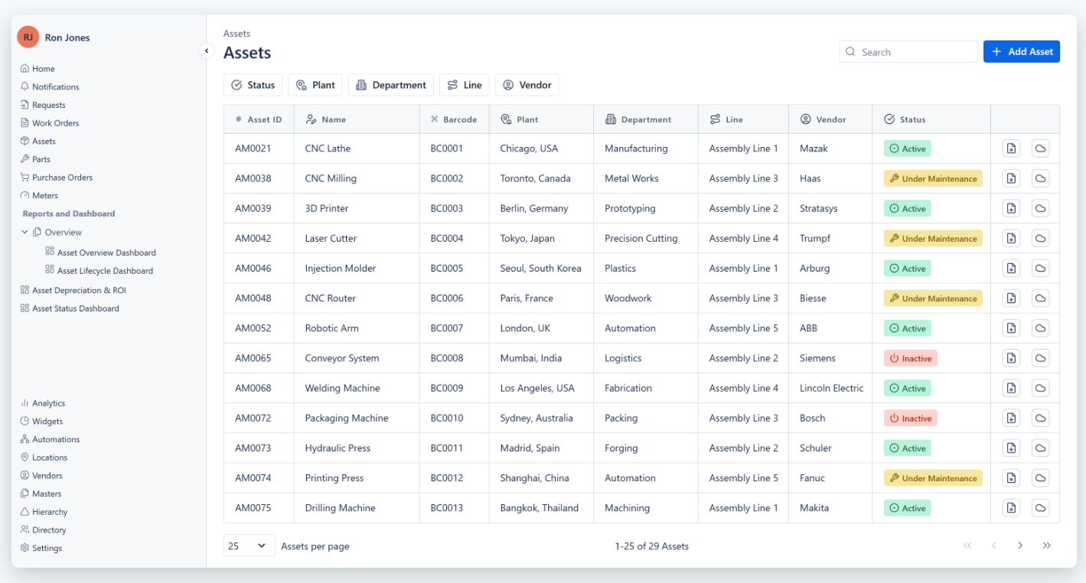

**Asset Management**

MachDatum's comprehensive asset management adapts to the industry workflow, empowering the industry to efficiently manage assets throughout their lifecycle — minimizing disruptions, reducing downtime, and ensuring seamless operations.  
  
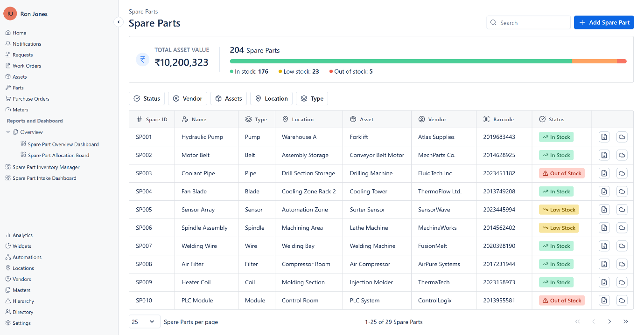

**Spare Part Management**

Track what's consumed, reorder what's needed, and avoid what's not. With full inventory sync and real-time insights, you're always stocked and never stuck.

**Nitriding Process Optimization for Gearbox Components**

<https://www.machdatum.com/use-cases/nitriding-process-optimization-for-gearbox-components>  
  
**Assembly Digitalization and Digital Valve Test Certificate**

<https://www.machdatum.com/use-cases/assembly-digitalization-and-digital-valve-test-certificate>  
  
**Wireless Process Monitoring for Kiln Operations**  
<https://www.machdatum.com/use-cases/wireless-process-monitoring-for-kiln-operations>  
  
**Utility Monitoring & Safety Automation**

[**https://www.machdatum.com/use-cases/utility-monitoring-and-safety-automation**](https://www.machdatum.com/use-cases/utility-monitoring-and-safety-automation) **Smart Production Monitoring for Cone Manufacturing**

[**https://www.machdatum.com/use-cases/smart-production-monitoring-for-cone-manufacturing**](https://www.machdatum.com/use-cases/smart-production-monitoring-for-cone-manufacturing) **Digital Quality Certificate for Gearbox Assemblies**

[**https://www.machdatum.com/use-cases/digital-quality-certificate**](https://www.machdatum.com/use-cases/digital-quality-certificate)